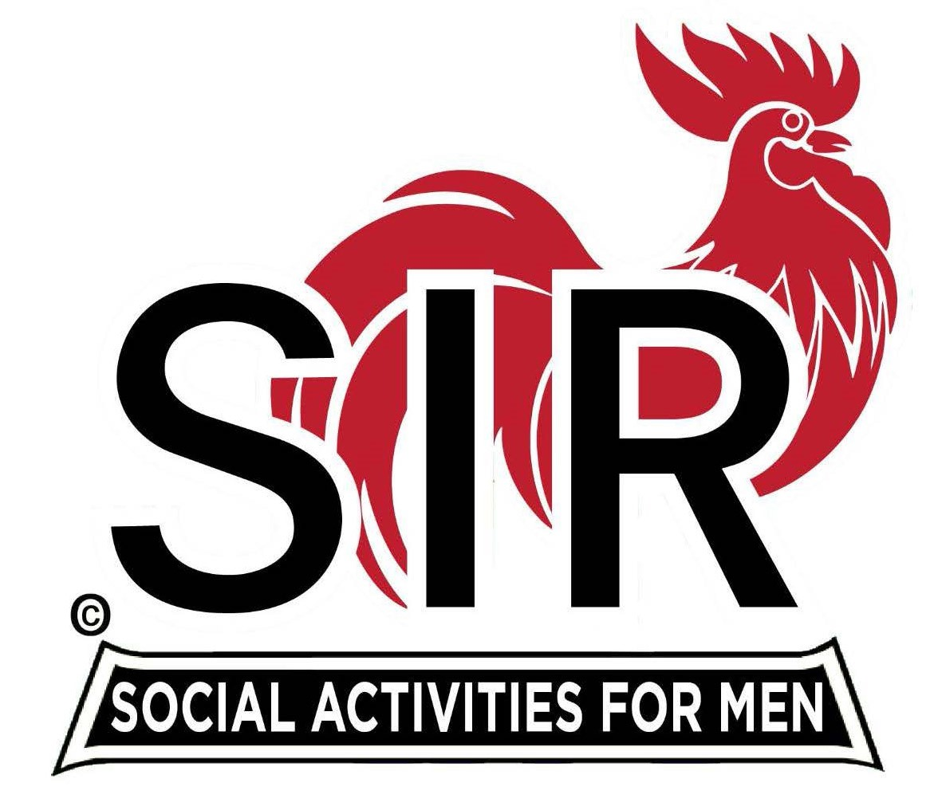
Las Trampas Branch 116
BEC Meeting Agenda
March 18, 2024, 9:15 AM at Boundary Oak
The Mission of SIR is to enhance the lives of our members through fun activities, events and luncheons while making friends for life.

9:15 am Call to order; Secretary, Dan Lawrence – Confirm quorum and
Approval of February 19, 2024 BEC meeting minutes

9:20 am Standing Reports

- Treasurer – Charlie Guthrie

- Luncheon Report – Dennis Snarr
  - March Lunch Count

- Membership – Greg Hughes
  - Membership Count

- RAMP Department Head Reports:

- Recruitment – Don Schroeder
  - New member: Harvey Widroe; Former Orinda Member
  - Guest: Dr. Noel Concepcion; Sponsor Peter Loew

- Activity Coordinator – Mike Ward

- Member Relations - Sam Beret
  - Member Survey Results – Sam Beret and Fred Wachowicz

- Publicity – Robin Lemmo
  - Results of advertising in Danville/Alamo today and Diablo Gazette

9:40 am Little SIR Updates – Paul Russell

- Speaker Info – Janet Hoy, League of Women Voters
- Birthday Boys – March

9:50 am Updates & New Business

- Results of SIR Branch Leadership Workshop
- Sunshine Report
- Spring Fling
- Contact from Byron Park/The Heritage

10:15 am Adjourn: Lunch Preparations

